4.2 Double Integrals over Nonrectangular Regions

Motivation: We want to be able to integrate two variable functions not just over rectangles but also over regions D of a more general shape.

Note: the derivation and exploration below will be done in class only if time permits. In any case, it is important to look through the derivation in order to attach some rigor to what we will be doing when integrating over type 1 and type 2 regions

Suppose we want to integrate the function over a bounded region D. Since D is bounded we know that it can be enclosed in a rectangle. A picture of what D might look like along with a rectangle it is contained in is:

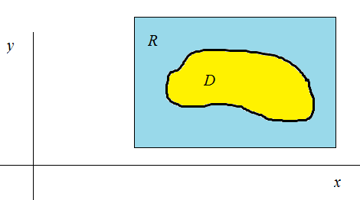
From here we define a new function .

Note that the signed volume of the solid bounded by D and should be the same as the signed volume of the solid bounded by R and since agrees with on and is 0 everywhere else on R. This key observation leads to the following definition.

Definition: If is integrable over , then we define the double integral of f over D by (where we are using the notation and symbols introduced in the motivation).

Definition: We say that a plane region D is a
- type 1 region if it lies between the graphs of two continuous functions of x, that is, where and are continuous on .

- type 2 region if it lies between the graphs of two continuous functions of y, that is, where and are continuous on .

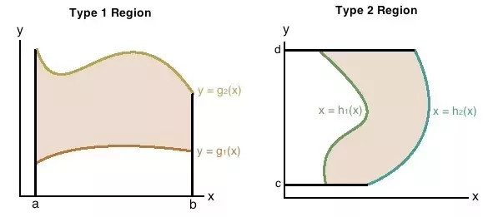

Exploration:
Suppose we wish to evaluate when is a type 1 region and is continuous on D. To do this, we pick a rectangle containing D. A picture of what R might look like is shown below.

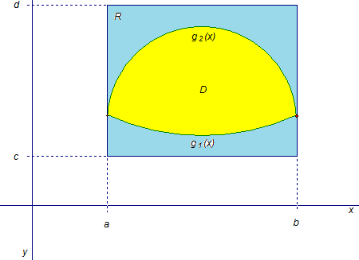
Then, it can be shown (though it is beyond the scope of this course) that
is integrable on R.

Then, we have by definition that .

Then, by Fubini’s theorem, we know that . Since when or and when , we have that

Thus, . This result tells us exactly how to use iterated integrals to find integrals of functions over type 1 regions.

We now summarize the results of the exploration above.

Theorem:
- If is continuous on a type 1 region D such that and both and are continuous on , then .
- If is continuous on a type 2 region D such that and both and are continuous on , then .

Question: Could we interchange the order of the integrals and differentials in the most recent theorem?

Example 1: Find the volume of the solid which is in the first octant and lies under the plane given by: .

A picture of the solid is shown at the right.

The solid which we are trying to find the volume of lies below the plane given by , and above the region (which we will call D) in the xy-plane shown below.

Since another way to write the equation of the plane is , we know that the desired volume is .

Now, we need to figure out a way to use the most recent theorem to find this double integral. One can notice that it is possible to represent D as a type 1 or type 2 region. In particular, , and . So, we can use part 1 or part 2 of the above theorem to find the double integral. We will arbitrarily choose to use part 2 of the theorem, and we calculate that
Note: One can check that if we use the integral (part 1 of the theorem) in the above example we obtain the same volume.

Question: Why would it be incorrect to use the iterated integral to find the desired volume in this example?

Answer: This would assuming that we are working over a rectangular region in the xy-plane which stretches with and !

Example 2: Suppose that D is the region in the xy-plane bounded by and . Use a double integral to find the volume of the solid that lies below the surface given by and above the region D.

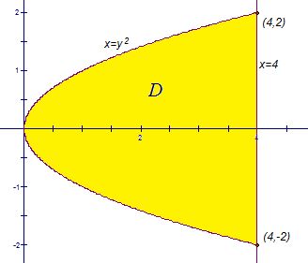
We first draw a picture of the region D.

We notice that it is most natural to think of D as a type 2 region. In particular, . So, the desired volume will be
OR
and
Example 3: Evaluate the iterated integral .
We immediately see that we cannot start evaluating the above integral since does not have an antiderivative that can be written in terms of elementary functions.

So, our strategy is to try to rewrite the iterated integral in a different way. We note that our region of integration is: . A picture of this region is shown at the right.

We can rewrite D as a type 2 region: . This means that
We can do the final single integral with a simple u substitution. We let , and we note that and . So, we have that
and we are finished.

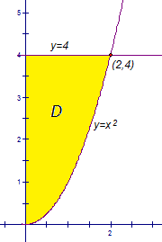
Example 4: Evaluate over the region D in the first quadrant which is bounded by the graphs , , and .

A picture of the region D is shown below. In set notation we can represent D as a type 1 or type 2 region: or . So we know that and . The first iterated integral is impossible to evaluate with antidifferentiation, but the second iterated integral is doable.

So, we calculate that . We now solve the single integral with a u-substitution. We let , and we note that and . So, we have that , and we are finished.
Double Integral Properties Over a Region D:

Assume that and exist. Also suppose that c is a constant. Then,
- If for all in D, then
- If where and don’t overlap except perhaps at the boundaries, then .
- If represents the area of D, then .
- If for all , then .

Example 5: Suppose that D is the region in the xy-plane bounded by and . Use a double integral to find the area of D.

We first draw a picture of the region D.


We notice that it is most natural to think of D as a type 2 region.
In particular, .
So, the area is given by:.

